AGENTSUDO WALKTHROUGH
Task1: Author Note:
Welcome to another THM exclusive CTF room. Your task is simple, capture the flags just like the other CTF room. Have Fun!
If you are stuck inside the black hole, post on the forum or ask in the TryHackMe discord.
Answer the questions below
Deploy the machine
No Answer needed.

Task2: Enumeration.
Enumerate the machine and get all the important information
Answer the questions below
#1 How many open ports?
Nmap -A 10.10.93.78
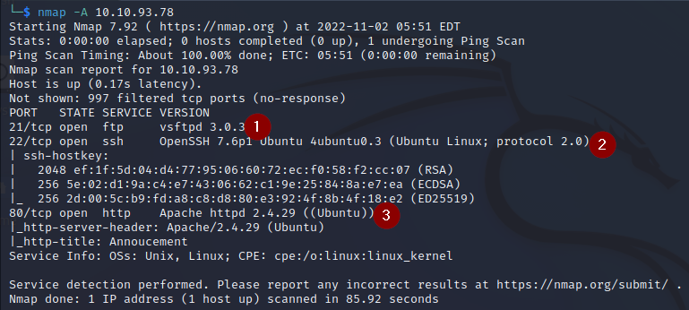

#2 How you redirect yourself to a secret page?
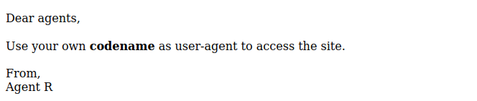

Answer: User-agent.

#3 What is the agent name?
Curl “http://10.10.93.78” -H “User-Agent:C” -L
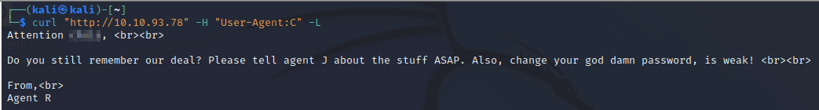

Answer: C@@@

Task3: Hashing and Brute-force
Done enumerate the machine? Time to brute your way out.

#1 FTP password
To view the ftp password run the below command:
Hydra -l christ -p /usr/share/wordlists/rockyou.txt ftp://10.10.93.78 -f
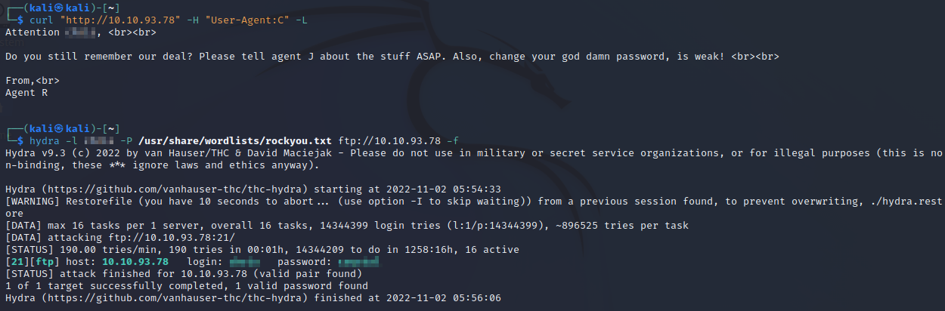

Now log in to the ftp server using the log in details find above
Command:
ftp 10.10.93.78
Username:
Password:
After successful login download the three files on your local machine using the below command:
get To_agentJ.txt
get cute-alien.jpg
get cutie.png

Open the To_agentJ.txt we got the below message which shows that we have to do something with those images.
cat To_agentJ.txt

Dear agent J,

All these alien like photos are fake! Agent R stored the real picture inside your directory. Your login password is somehow stored in the fake picture. It shouldn't be a problem for you.

From,
Agent C

We are going to binwalk to extract all the hidden files in the image
Binwalk is a tool for searching a given binary image for embedded files and executable code. Specifically, it is designed for identifying files and code embedded inside of firmware images. Binwalk uses the libmagic library, so it is compatible with magic signatures created for the Unix file utility.
Use the below command to extract all the hidden files
binwalk -e cutie.png
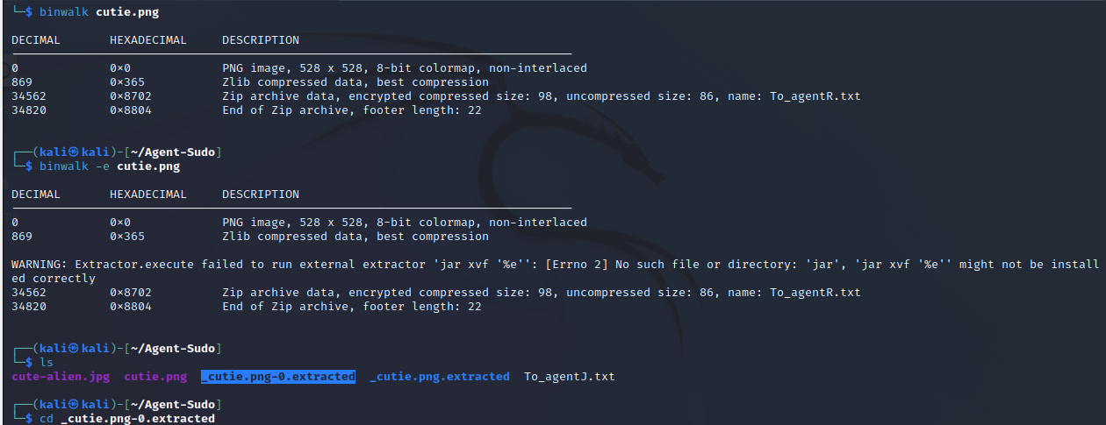

Move to the new directory created after the extraction to see the zip file
cd _cutie.png.extracted
ls

We are going to use zip2john command line to get the hashed file to a txt file
zip2john 8702.zip > zip.password
After this use john to crack the password.
john zip.password
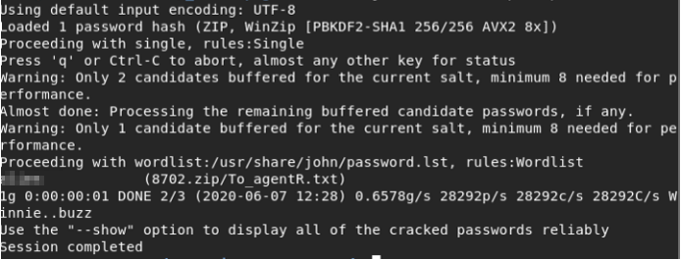

#2 Zip file password
Answer: “a@@@@”

Unzip the zip file using the below command
7z e 8702.zip then input the password find above when prompted.
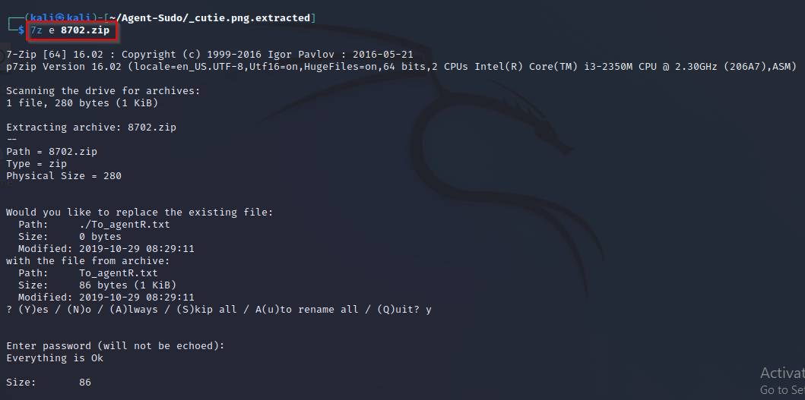

Open the extracted text file called To_agentR.txt.
Command: cat To_agentR.txt
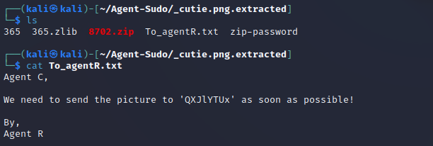
We found another hashed password “QXJlYTUx”
I used cyberchef to crack this password
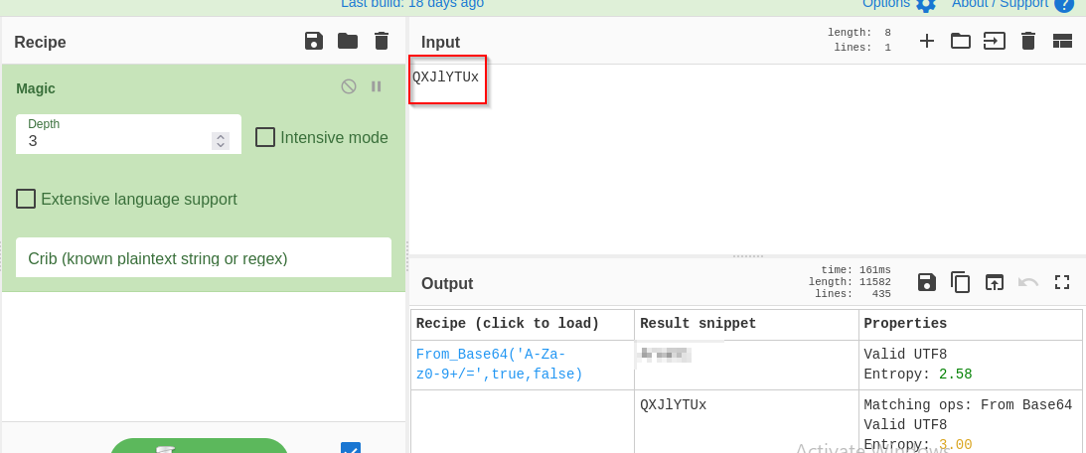
#3 steg password
Answer: A@@@@

Next is to analyse the second image cute-alien.jpg. From the message we read before shows that something is hidden inside the image. So we are going to use a command line tool called steghide to do this analysis.
Steghide is steganography program which hides bits of a data file in some of the least significant bits of another file in such a way that the existence of the data file is not visible and cannot be proven. Read more about this tool and how to using it on https://www.kali.org/tools/steghide/

Commands:
steghide info cute-alien.jpg = to get information about the embedded data
steghide extract -sf cute-alien.jpg = to extract the data

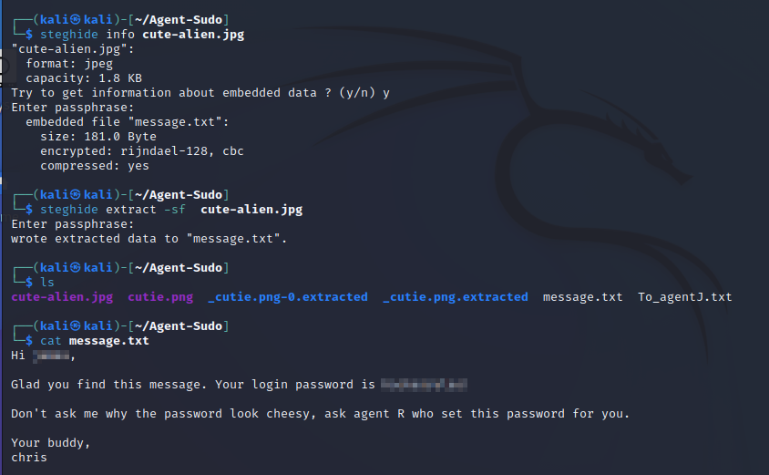
After the extraction the open the file to see the name of the other user and its login password.
#4 Who is the other agent (in full name)?
Answer: j@@@

#5 SSH password
Answer: H@@@@@@@!

Task4: Capture the user flag.

Use the credentials we found above to login to the ssh server.
Commands:
ssh username@10.10.93.78
Put the password when prompted
ls
cat user_flag.txt

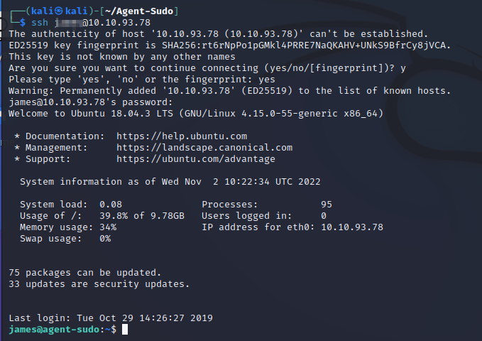
#1 What is the user flag?
Answer: b@@@@@@@@@@@@@@@@@@@@@@7

#2 What is the incident of the photo called?
Open another terminal and make a new directory called Autopsy and use the command below to download the image found on the user directory called Alien_autospy.jpg and do reverse image search on google.
james@10.10.249.75:Alien_autospy.jpg ~/
I restarted the machine that’s why my IP changed.

https://www.labnol.org/reverse/
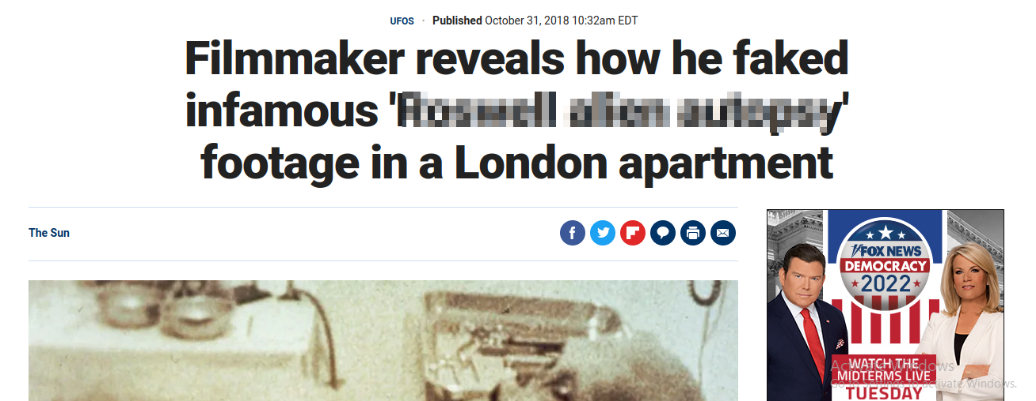

Answer: R@@@@ @@@@@ @@@@@y
Task5: Privilege escalation

#1 CVE number for the escalation

On the user terminal run this command, sudo -l to know if the user is privileged to run sudo command without providing the root password which will help us to escalate our privilege to root user.
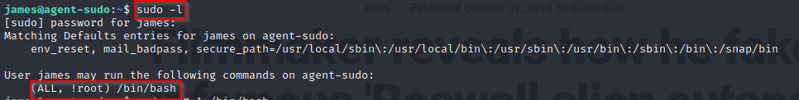
From the result we got above, we are going to search for possible way to exploit the misconfiguration so as to escalate our privilege to root user.
Search for (ALL, !root) /bin/bash
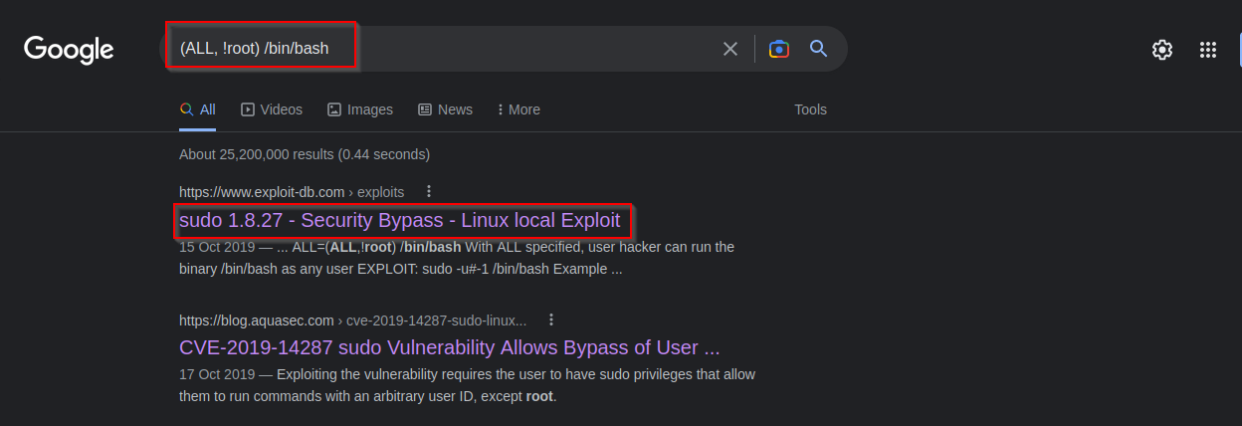
From our search we found possible way to bypass the security and escalate to root user.
Answer: CVE-2019-14287

#2: What is the root flag?
Use the exploit code we found above to bypass the security policy and escalate to root user.
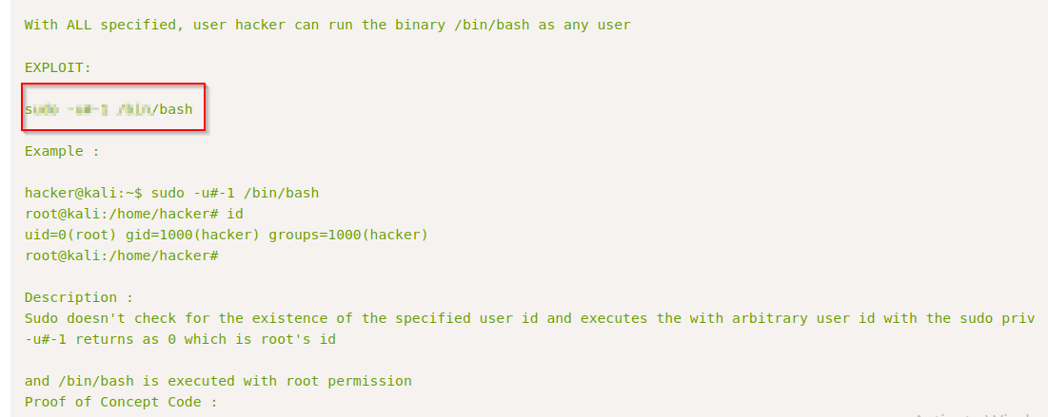
After executing the above command, navigate to root directory to see the root flag and the name of the Agent R.
